Q1. 2015 Quiz

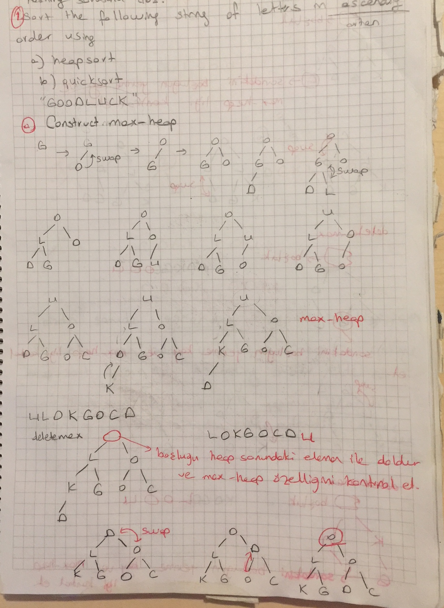

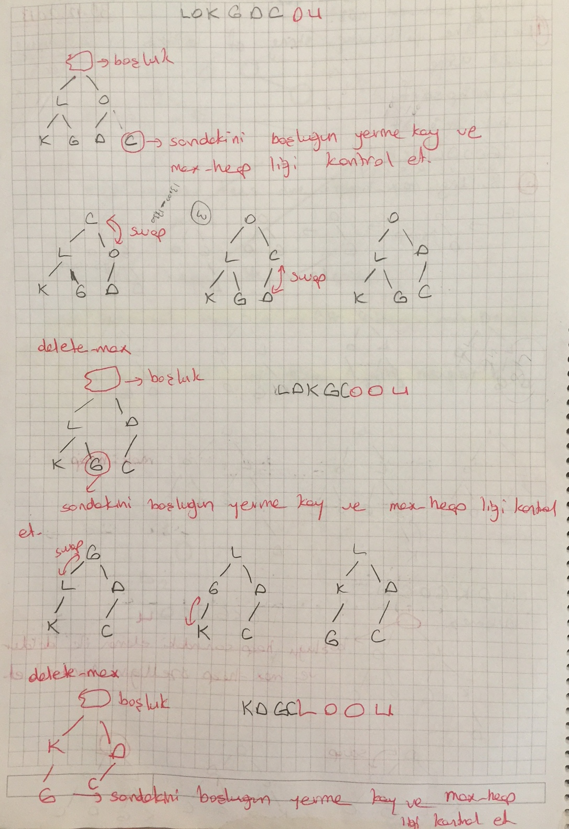

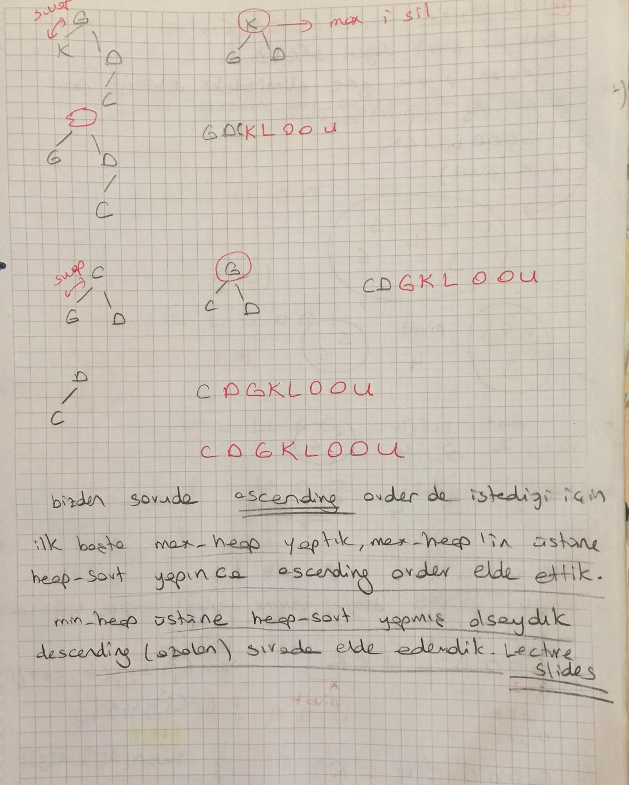

Q2. 2015 (15 pts) (HOMEWORK)
Sort the following string of letters in descending order using heapsort?(For full credit show all steps)

UNIVERSITY

E
/ \
I N
/ \ / \
I U R S
/ \ /
V T Y

After heapsort

Y V U T S R N I I E

Q3. 2018 FINAL EXAM
- (10+10=20 pts)Consider the following list of words:

atatürk, tarih, cumhuriyet, demokrasi, yurt, fatih, gazi, hayat

a) Alphabetize the above list using an insertion sort. Show your work.

original: atatürk, tarih, cumhuriyet, demokrasi, yurt, fatih, gazi, hayat
1st pass: atatürk,| tarih, cumhuriyet, demokrasi, yurt, fatih, gazi, hayat

At the first pass onlt the first key is placed in its correct position,

Atatürk is inserted in the correct place

| means that all the keys on the left of | are sorted.

2nd pass: atatürk, tarih, | cumhuriyet, demokrasi, yurt, fatih, gazi, hayat
3rd pass: atatürk, cumhuriyet, tarih, | demokrasi, yurt, fatih, gazi, hayat
4th pass: atatürk, cumhuriyet, demokrasi, tarih, | yurt, fatih, gazi, hayat
5th pass: atatürk, cumhuriyet, demokrasi, tarih, yurt, | fatih, gazi, hayat
6th pass: atatürk, cumhuriyet, demokrasi, fatih, tarih, yurt, |gazi, hayat
7th pass: atatürk, cumhuriyet, demokrasi, fatih, gazi, tarih, yurt,| hayat
8th pass: atatürk, cumhuriyet, demokrasi, fatih, gazi, hayat, tarih, yurt

b) Alphabetize the above list using a bubble sort. Show your work.(HOMEWORK)

original: atatürk, tarih, cumhuriyet, demokrasi, yurt, fatih, gazi, hayat
1st pass: atatürk, tarih, cumhuriyet, demokrasi, yurt, fatih, gazi, hayat
atatürk, cumhuriyet, tarih, demokrasi, yurt, fatih, gazi, hayat
atatürk, cumhuriyet, demokrasi, tarih, yurt, fatih, gazi, hayat
atatürk, cumhuriyet, demokrasi, tarih, yurt, fatih, gazi, hayat
atatürk, cumhuriyet, demokrasi, tarih, fatih, yurt, gazi, hayat
atatürk, cumhuriyet, demokrasi, tarih, fatih, gazi, yurt, hayat
atatürk, cumhuriyet, demokrasi, tarih, fatih, gazi, hayat, yurt
(After 1st full pass, we know ”yurt” is in the correct place.)
2nd pass: atatürk, cumhuriyet, demokrasi, tarih, fatih, gazi, hayat, yurt
atatürk, cumhuriyet, demokrasi, tarih, fatih, gazi, hayat, yurt
atatürk, cumhuriyet, demokrasi, tarih, fatih, gazi, hayat, yurt
atatürk, cumhuriyet, demokrasi, fatih, tarih, gazi, hayat, yurt
atatürk, cumhuriyet, demokrasi, fatih, gazi, tarih, hayat, yurt
atatürk, cumhuriyet, demokrasi, fatih, gazi, hayat, tarih, yurt

Q4. 2014 (10pts)
Consider the sequence of keys below:

10 19 13 a b 29 67 23 47 c d 53 37

- Determine the pivot by median-of-3 selection method and swap the last key (i.e., 37) with the pivot if necessary!

Median of 3 pivot selection:

The first middle and last keys: 10, 67, 37.
Sort the list: 10, 37, 67.
Take the middle as the pivot: 37.

Our first pivot is 37. Hence, we swap 37 with the last key. But, 37 itself is the last key; hence no swaps necessary!

Q5. 2013(6+10= 16pts)
Here is an array which has just been partitioned by the first step of quicksort:
12 13 7 16 18 23 26 19 30

a) Which of these elements could be the pivot? If there are more than one possibility, show each possible element.
16, 18, 30

- (HOMEWORK) Considering your answer in “a”, perform the second step of quicksort using Hoare's partitioning algorithm we discussed in class!

Select :16 as pivot and apply quick Sort

